Brain Tumor Detection USING CNN

# Rishab Gupta, Kshitij Gupta

***Abstract*: *A tumor is defined as a lump that grows abnormally without any control. In most of the cases the tumor is dangerous. At an early stage, a brain tumor can be a tough task even for doctors to figure out. Using MRI Images is not always reliable, because MRI images contain noise and other disturbances, so hence it becomes difficult for doctors to identify tumor and their causes. So, this is where Image Processing comes, few of its techniques are used to recognize the image of interest in order to visualize the images easily. We propose a system which detects tumor from brain MRI images. First, we do processing of the image by converting the given image into a grey scale image and some filters are applied like bilateral or Gaussian or median filter to filter noise and other disturbances from the image and find out contours of the image, then we construct the CNN layers and perform binary classification using Convolutional neural network.***

***Index Terms*: *Tumor Detection, Convolutional Neural Network, Gaussian Filters.***

## INTRODUCTION

The human body is composed of many types of cells. Each cell has a specific function. The cells in the body grow and divide in an orderly manner and form some new cells. These new cells help to keep the human body healthy and properly working. When some cells lose their capability to control their growth, they grow without any order. The extra cells formed form a mass of tissue which is called tumor.

These tumors can be benign or malignant. Malignant tumors lead to cancer while benign tumors are not cancerous. Brain tumor occurred when the cells were dividing and growing abnormally. It is appearing to be a solid mass when it diagnosed with diagnostic medical imaging techniques. There are two types of brain tumor which is primary brain tumor and metastatic brain tumor. Primary brain tumor is the condition when the tumor is formed in the brain and tended to stay there while the metastatic brain tumor is the tumor that is formed elsewhere in the body and spread through the brain.

The symptom having of brain tumor depends on the size, location and type of the tumor. It occurs when the tumor compressing the surrounding cells and gives out pressure. Besides, it is also occurring when the tumor blocks the fluid that flows throughout the brain. The common symptoms are having headache, nausea and vomiting, and having problem in balancing and walking.

With the improvement of modern medical standards, medical imaging technology plays an increasingly important role in daily medical diagnosis and medical research. Therefore, research on medical diagnostic image data is very important. As a tumor disease with frequent occurrence and complexity, brain tumor has become a key research topic in the medical field. The diagnosis of brain tumors is usually based on imaging data analysis of brain tumor images. Accurate analysis of brain tumor images is a key step in determining a patient's condition. However, the accumulation of doctors personal medical knowledge, differences in experience levels, and visual fatigue can affect the correct analysis of image results.

According to the Indonesian Ministry of Health, in 2018 Indonesia became the 8th largest cancer patient in Southeast Asia and ranked 23rd in Asia[1]. Brain tumors are the second leading cause of death in cancer after breast cancer. In all cases, it is known that women are more affected by brain tumors than men. Brain tumors have continued to increase in incidence over the past decade in several countries [2]. Medical imaging is a key factor in diagnosing brain tumors and can help prevent the most dangerous diseases. MRI is a imaging technique that researchers rely on to detect brain tumors [3]. MRI is one of the most widely used imaging techniques for brain tumors because it does not use ionizing

radiation [4].

Therefore, how to accurately detect brain tumor images is very important and this is the reason which motivate us to work on them. In this paper, we were asked to experiment with a

real-world dataset of brain tumor, and to explore how deep learning algorithms can be used to detect the image consist tumor in the dataset. We were expected to gain experience using deep learning algorithms and various libraries are used for data visualization, transformation etc. So, our main objective of this project is to classify the tumor or non-tumor images using deep learning algorithms. To gain the main objective of this project we had done many smaller objectives like augmentation, cropping, visualization, transforming and many more.

## LITERATURE SURVEY

**2.1. Convolutional Neural Network**

CNN is a neural network that aims to process data with grid structure. Convolution is a function in the convolution layer based on algebraic line function that duplicates the filter matrix in an image for processing [5]. The convolution layer is the most important layer to apply. Another type of layer commonly used is a composite layer, which is a layer used to take the maximum or average number of pixel segments of an image.

CNN has the ability to learn complex features by creating a feature map. The convolution layer kernel is wrapped in an input sample to count a few feature maps. Features are found in input samples rather than those represented by small boxes on the feature map. These maps are transferred to the top collection layer, which stores the relevant features and discards some. The features of the max-pooling layer are converted to the vector of one-sided element into a fully connected layer, which is then used to calculate the output potential. The CNN suspension is shown in Figure 1 [6].

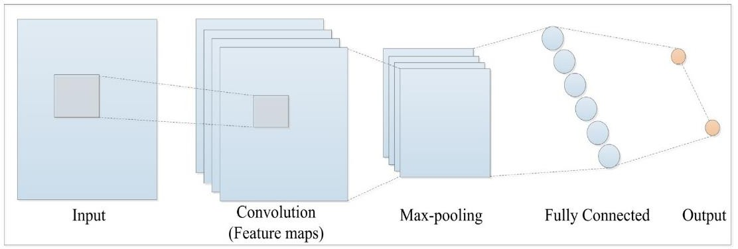

**Figure 1.** CNN architecture [10]

**2.1.1. Convolution Layer**

Convolution Layer is the core layer in the CNN method which aims to extract features from the input. Convolution performs linear transformations of input data without changing spatial information in thedata. Convolution kernels are determined from the weight of the layer so that the convolution kernels can process the input data training on CNN.

**2.1.2. Subsampling Layer**

CNN uses Max Pooling as a sampling method. The way Max Pooling works is to divide the output of a convolution layer into a few smaller grids and subtract the maximum value for each grid to produce a small image matrix. With a smaller image size it will make it easier to process the next layer of convolution.

**2.1.3. Fully Connected Layer**

The Fully Embedded layer changes the size of the data to be categorized. In the convolution layer, each neuron must be converted into one-sided data before it can be incorporated into another interconnected layer [6]. This process is caused by data loss of its location information and at the end of the Fully Connected Layer Network is used.

**Method**

**3.1. Dataset**

The dataset used in this study is Brain MRI Images for Brain Tumor Detection obtained from kaggle.com. The dataset consists of 3000 images grouped into 2 groups, 1500 brain images that have tumors, and 1500 brain images that do not have tumors.

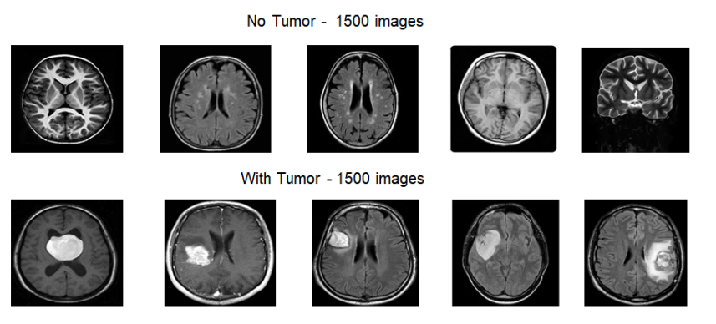

**3.2. Proposed Method**

In this paper, we have detect the whether an MRI image contain brain tumor or not. For this we have used the image dataset. This will be done in many phases. After importing dataset, we have converted image into grey scale image and blur it slightly. Some filters are applied to filter noise and other disturbances from the image and find out contours of the image and afterwards, we crop the image. The images are split into training, testing, validation dataset. We plot the bar graph for better visualization of dataset distribution. After this we have done the zero padding to maintain the dimensions of image to after filtering.

Then we construct the CNN layers and perform classification. This is a binary class classification as the output is 0 or 1, which means normal or tumor.

**3.3 About CNN**

CNN stands for convolutional neural network. Convolution Neural Network is an algorithm that is used in our paper for the identification of 2D image and to get information from it. It has mainly has the following layers: input layer, zero padding layer, convolution layer, max pooling layer, and fully connected layer. It require less preprocessing as compare to other image classification algorithm.

**3.4 Input Layer**

Input layer should contain image dataset. Image is represented by three cross three matrix. You need to reshape into single column.

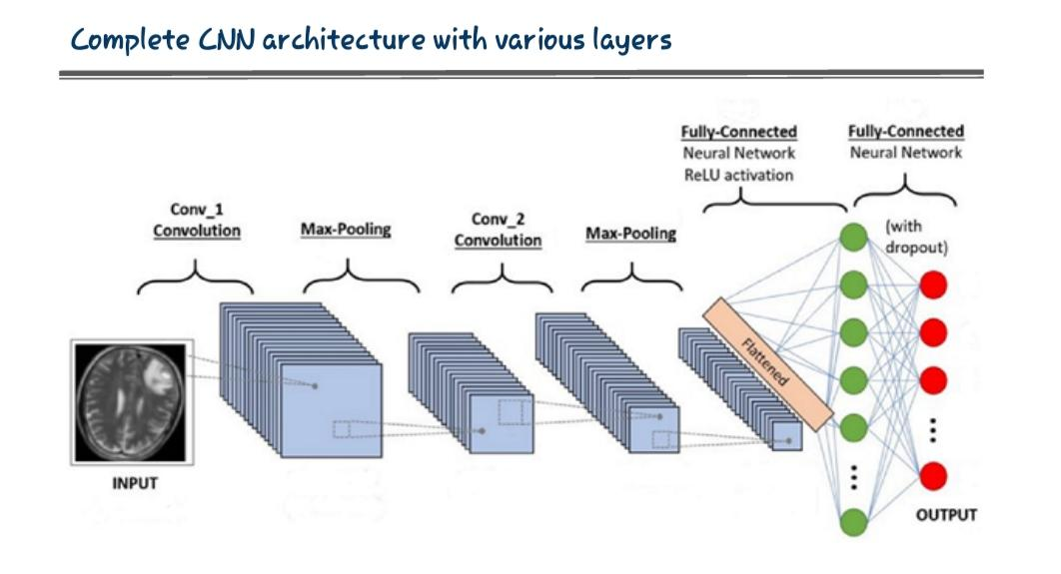

**3.5 Convolution Layer**

A convolutional layer contains a set of filters whose parameters need to be learned. The height, width of the image volume is greater than the image filter. Filter slides across the width and height of the input. Dot product between input and filter is calculated at the spatial position. The output volume of the convolutional layer is obtained by stacking the activation maps of all filters along the depth dimension. Since the width and height of each filter is designed to be smaller than the input, each neuron in the activation map is only connected to a small local region of the input volume.

**3.6 Polling Layer**

This layer is usually in cooperated between two successive convolutional layer. Pooling

layers are used to reduce the dimensions of the feature maps. Thus, it reduces the number of parameters to learn and the amount of computation performed in the network. It summarizes the feature present in the region of the feature map which is generated by convolutional layer. Due to this further operations are performed on summarized features instead of precisely positioned features generated by the convolution layer. By this model become robust to variation in the position of the features in the input images. Max pooling is one type of pooling layer.

**3.7 Fully Connected Layer**

This layer is the essential component of Convolutional Neural Networks (CNNs), which have been proven very successful in recognizing and classifying images for computer vision. The Convolutional neural network process begins with convolution and pooling, breaking down the image into features, and analyzing them independently. The result of this process feeds into a fully connected neural network structure that drives the final classification decision.

EXPERIMENT

In this project we have detect the whether an MRI image contain brain tumor or not. For this we have used the image dataset. This will be done in many phases. After importing dataset, we have converted image into grey scale image and blur it slightly. Some filters are applied to filter noise and other disturbances from the image and find out contours of the image and afterwards, we crop the image. The images are split into training and testing dataset. We plot the bar graph for better visualization of dataset distribution. Then we construct the CNN layers and perform classification. This is a binary class classification as the output is 0 or 1, which means normal or tumor.

**4.1 Image Analysis**

**Contour:** It is very useful to calculate the effective area in the image. After that, we have grabbed the largest contour using imutils.grab_contours() and max() function respectively as shown in given figure.

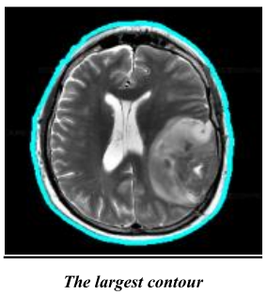

**Cropping:**

It is the processing in which we will remove the extra part of image by calculating extreme points in the image. That’s why, we have calculated four extreme points (left extreme, right extreme, top extreme and, bottom extreme point) to crop the images. After cropping the image will look like as image shown in given figure.

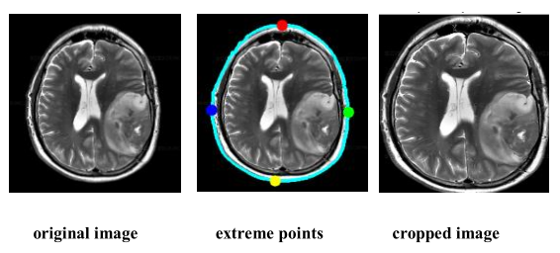

**Resizing of image:**

Sometimes, it is necessary to increase the size of the image to perform the detection operation easily. So, we use cv2.resize() function provided by OpenCV to resize the image.

**Visualization of images:**

Since, we need a visual summary of information which makes it easier to identify patterns and trends. For that purpose, we have used imshow() function of Matplotlib library which is used to display the images.

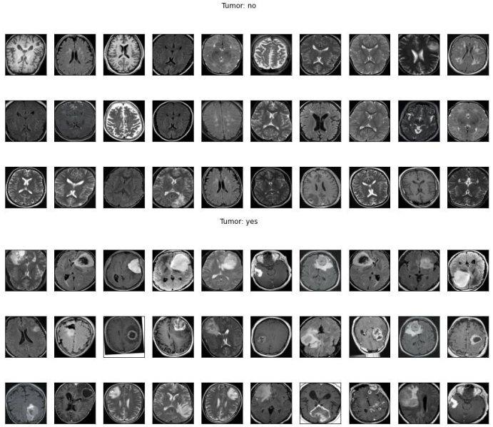

We have also used iplot() function to get interactive plots and used to display the no of classes in the training and testing dataset.

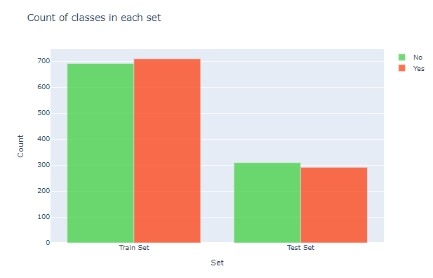

**RESULT**

**Accuracy of the model—**

Accuracy is evaluating the performance of the model by finding that how much the predicted results by the model are correct in compare to real data. For that purpose, we have used plot_metrics() and confusion metric to get accuracy.

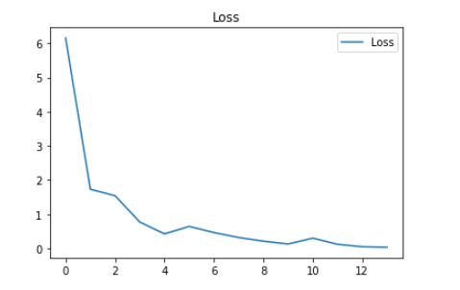

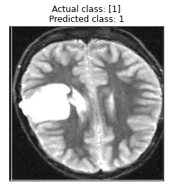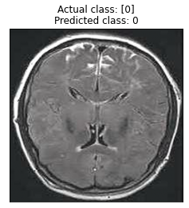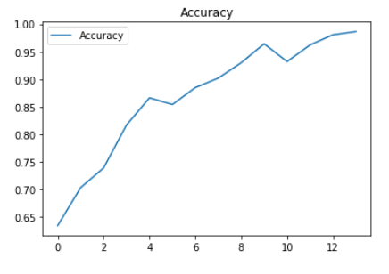

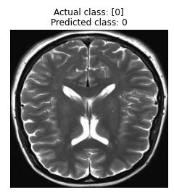

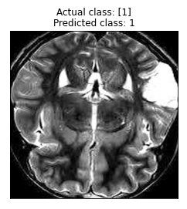

* Confusion matrix showing the validation accuracy in the fig.
* Blue color of matrix shows the validation accuracy ratio
* White color represents the validation loss ratio

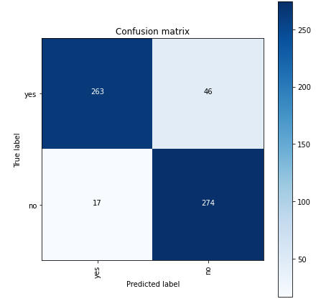

As a result, we got an accuracy of 95% through binary classification and our model predicts the images as shown below:

## REFERENCES

1. “Penyakit Kanker di Indonesia Berada Pada Urutan 8 di Asia Tenggara dan Urutan 23 di Asia.”
2. S. EDY, W. I, and W. A, “Clinical Characteristics and Histopathology of Brain Tumor at Two Hospitals in Bandar Lampung,” Fac. Med. Lampung Univ., vol. 69, pp. 48–56, 2014.
3. H. Mohsen, E.-S. A. El-Dahshan, E.-S. M. El-Horbaty, and A.-B. M. Salem, “Classification using deep learning neural networks for brain tumors,” Futur. Comput. Informatics J., vol. 3, no. 1, pp. 68–71, 2018.
4. M. H. Avizenna, I. Soesanti, and I. Ardiyanto, “Classification of Brain Magnetic Resonance Images Based on Statistical Texture,” Proc. - 2018 1st Int. Conf. Bioinformatics, Biotechnol. Biomed. Eng. BioMIC 2018, vol. 1, pp. 1–5, 2019.
5. K. P. Danukusumo, Pranowo, and M. Maslim, “Indonesia ancient temple classification using convolutional neural network,” ICCREC 2017 - 2017 Int. Conf. Control. Electron. Renew. Energy, Commun. Proc., vol. 2017-January, pp. 50–54, 2017.
6. S. Hussain, S. M. Anwar, and M. Majid, “Segmentation of glioma tumors in brain using deep convolutional neural network,” Neurocomputing, vol. 282, pp. 248–261, 2018.
7. https://en.wikipedia.org/wiki/Convolutional_neural_network ,December, 21 2019.
8. https://en.wikipedia.org/wiki/Loss_function , December, 21 2019